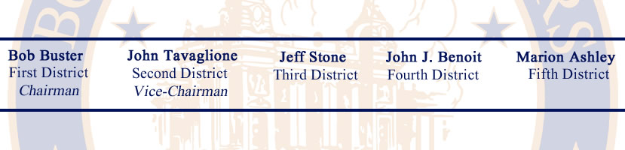

AGENDA
MONDAY, JUNE 13, 2011
BOARD OF SUPERVISORS – COUNTY OF RIVERSIDE
1ST FLOOR – COUNTY ADMINISTRATIVE CENTER
4080 Lemon Street, Riverside, California
(Clerk 951-955-1060)

______________________________________________________________________________

Budget Hearing Schedule
Fiscal Year 2011-12 Recommended Budget

Opening Comments 9:00 a.m.
County Executive Officer

Public Comment

General Government
Assessor-County Clerk-Recorder
Registrar of Voters

Break 10:15 a.m. – 10:30 a.m.

Public Protection
Probation
Fire

Lunch Break 11:00 a.m. – 1:30 p.m.

Sheriff
District Attorney

Health and Sanitation
Public Assistance
Education

