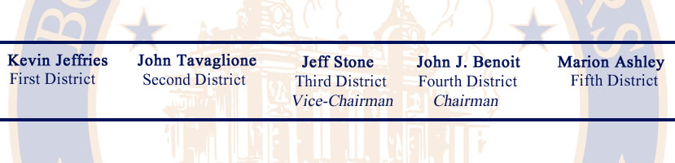

SPECIAL MEETING
AGENDA
WEDNESDAY, FEBRUARY 13, 2013
BOARD OF SUPERVISORS – COUNTY OF RIVERSIDE
1ST FLOOR – COUNTY ADMINISTRATIVE CENTER
4080 Lemon Street, Riverside, California
(Clerk 951-955-1060)

8:30 A.M.

3-1 SUPERVISOR BENOIT AND SUPERVISOR TAVAGLIONE: Offer of Reward for information leading to the arrest and conviction of Christopher Jordon Dorner.

3-2 SUPERVISOR ASHLEY: Offer of Reward for information leading to the arrest and conviction of the person(s) responsible for the deaths of Maria and Connie Gonzalez.

_____________________________________________________________________________________

ORAL COMMUNICATION FROM THE AUDIENCE ON ANY MATTER WHICH DOES NOT APPEAR ON THE BOARD’S AGENDA
_____________________________________________________________________________________

